第三次课程实验

实验a： 制作HTML5页面

（1）包含一个主页面，2个分页面。

（2）主页面要求如下：3个图像拼接并定位于居中位置，作为3个分页面的导航条。

（3） 第一个分页面图像为背景并设置透明度，含音乐播放器，并居中。参考例子14.7，歌词展示于overflow框中（居右）。设置返回按钮。

（4） 第二个分页面：

参考无缝轮播图案例，展示自选的图片（如果展示6 张图片更佳）

图片浮动或定位于此，显示时间日期，圆角边框。

参考京东狗案例实现替换图片（或者小猫图片，悬停后转老虎图片）

下部区域三角梅图片平铺做背景。居中实现视频播放器。

效果如下：

1）主页面

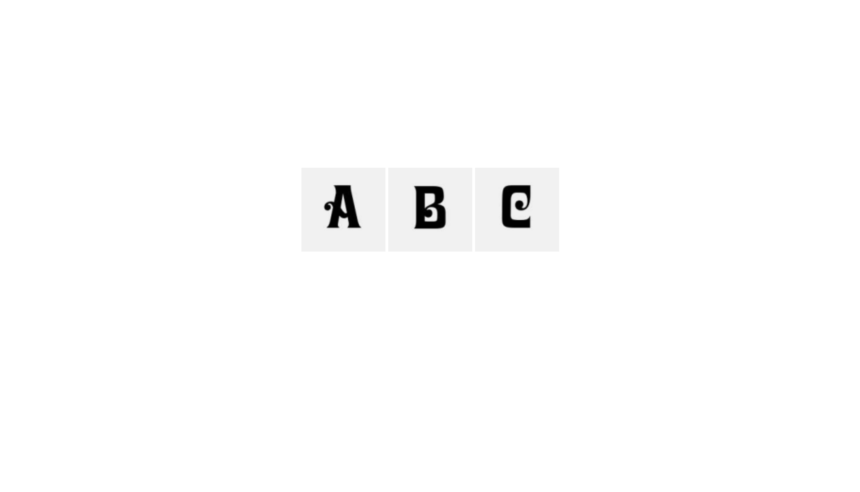

2）第一个分页面

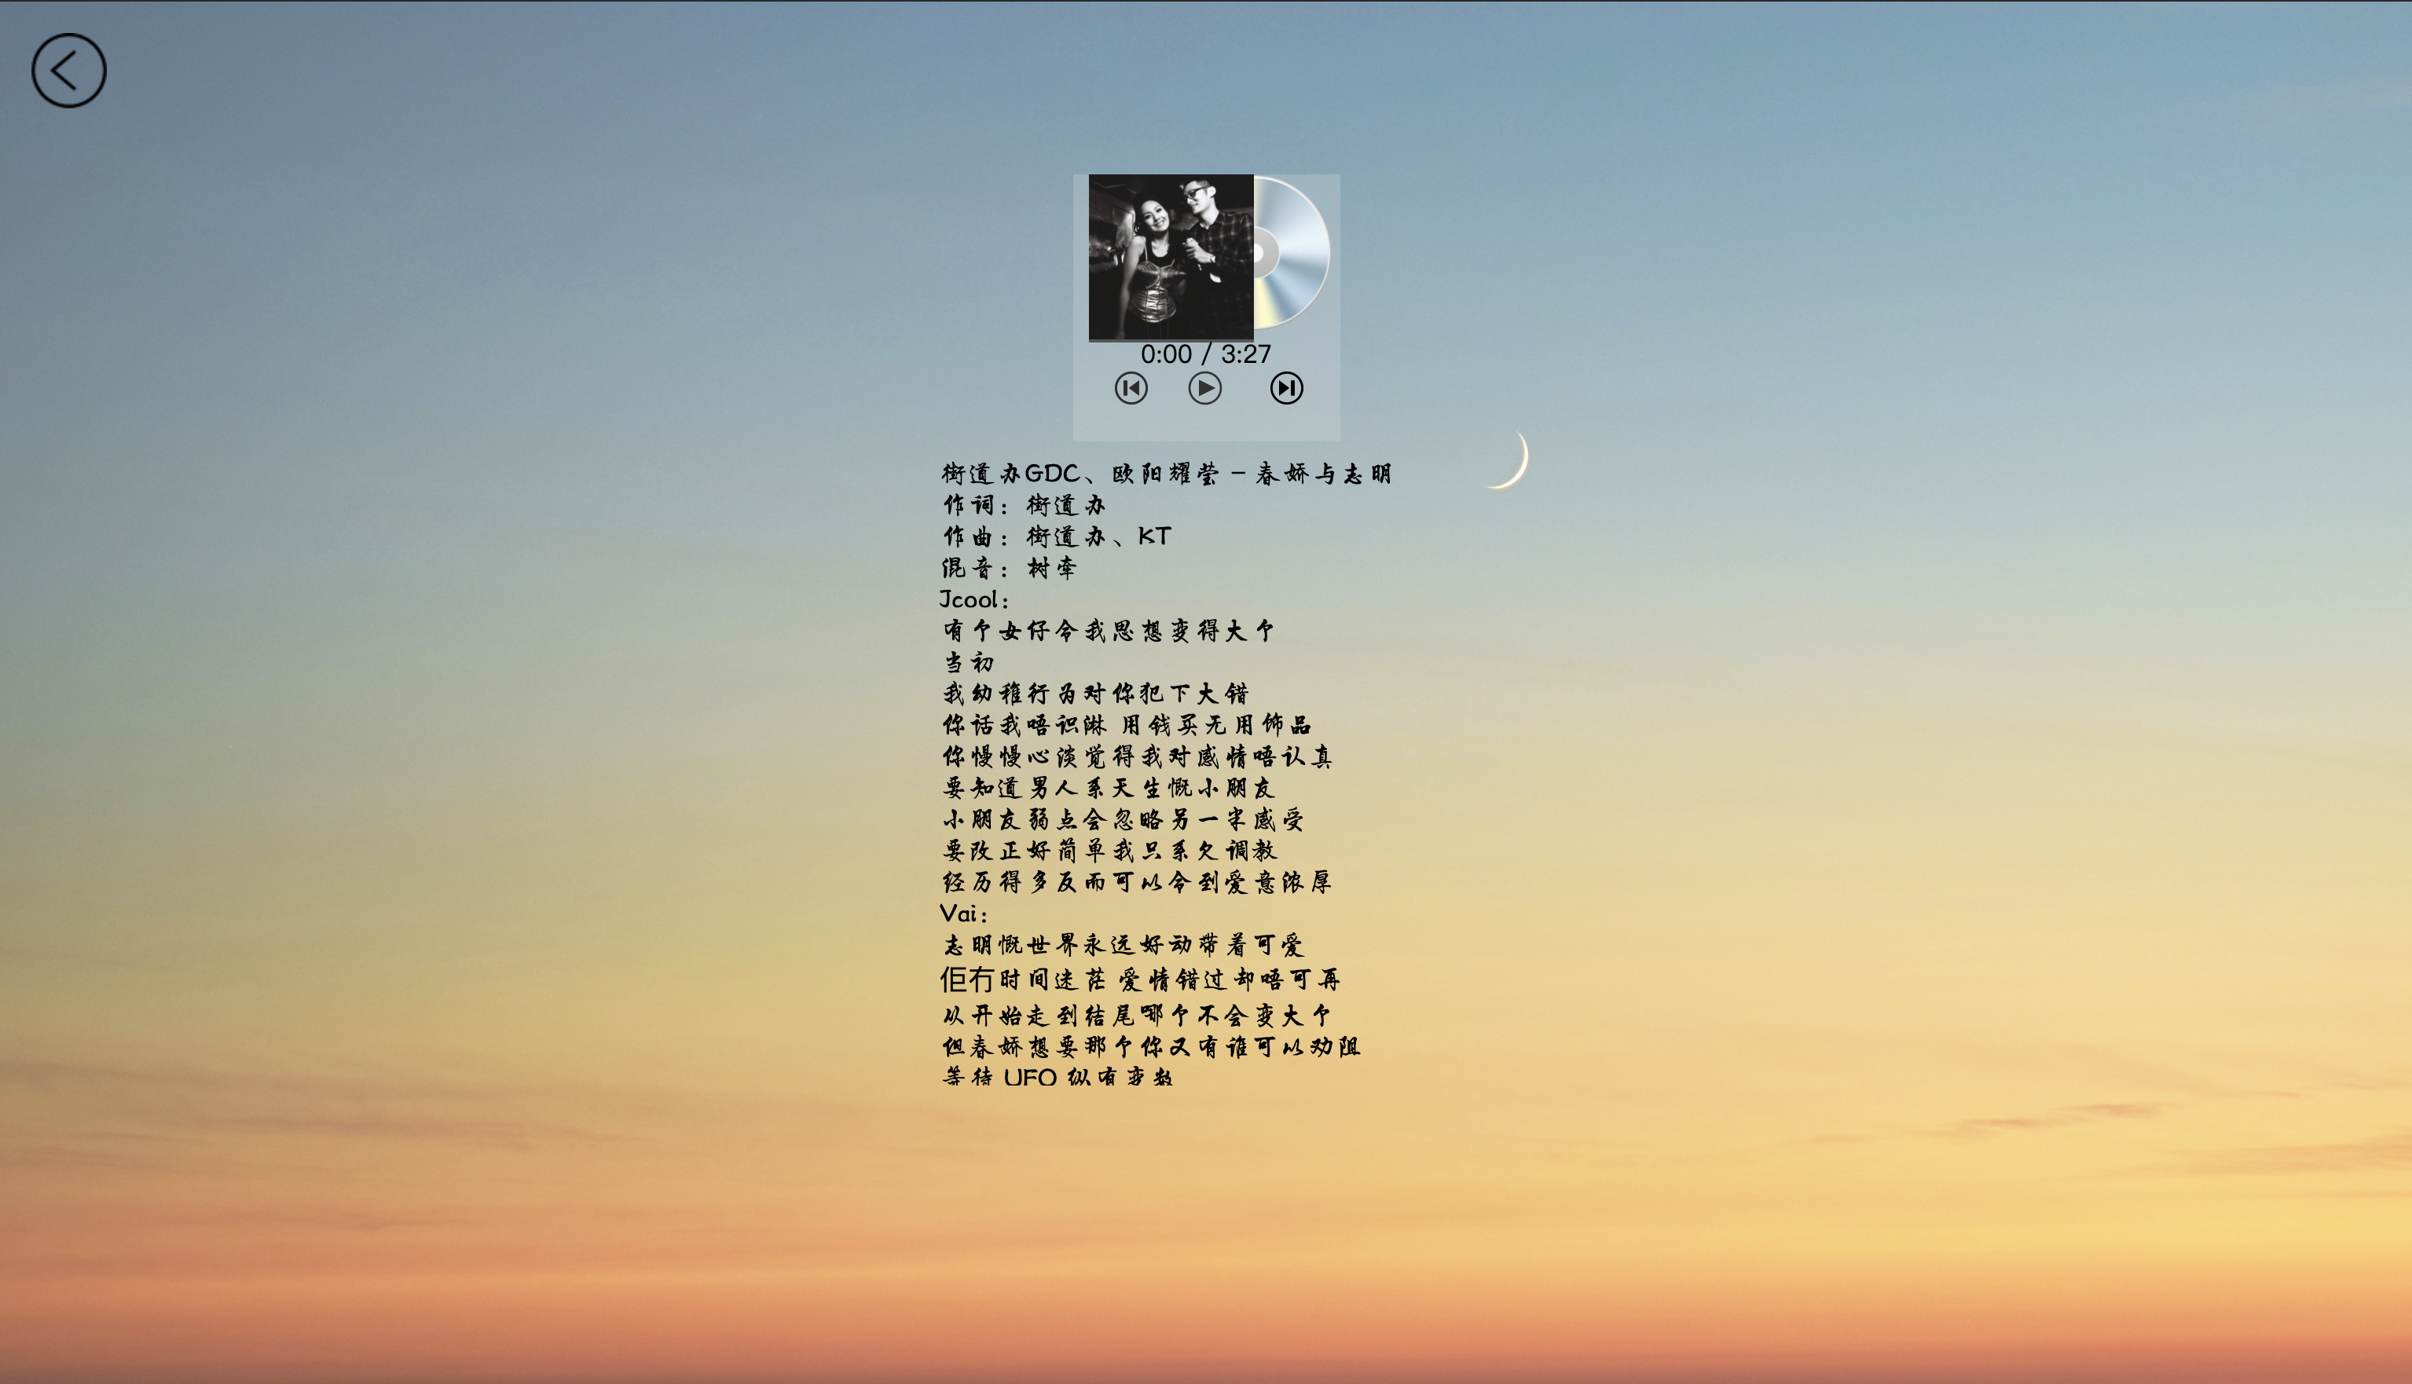

3）第二个分页面

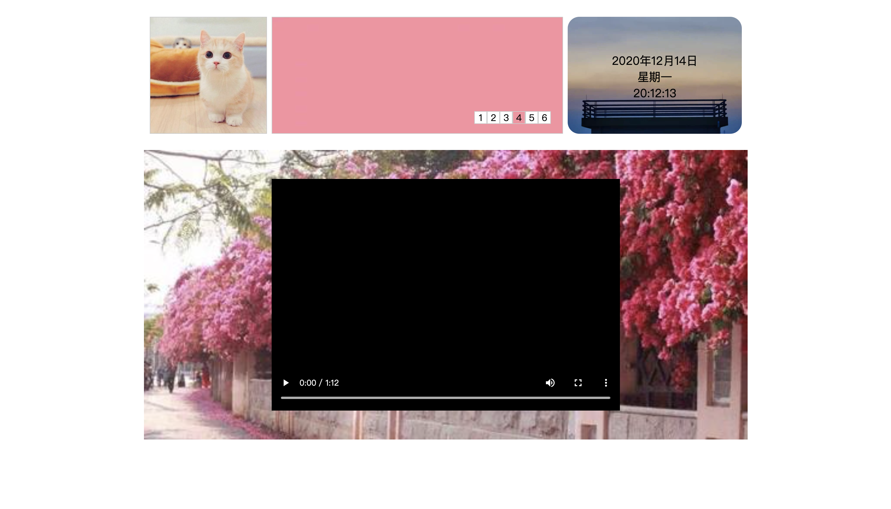

主要代码如下：

Html代码

1）index.html

<!DOCTYPE html>

<html lang="en">

<head>

<meta charset="UTF-8">

<title>Document</title>

<link rel="stylesheet" href="./css/index.css">

</head>

<body>

<div class="container">

<a href="./index.html"><img src="./image/A.png" alt="A"></a>

<a href="./pageA.html"><img src="./image/B.png" alt="B"></a>

<a href="./pageB.html"><img src="./image/C.png" alt="C"></a>

</div>

</body>

<script src="./js/index.js"></script>

</html>

2）pageA.html

<!DOCTYPE html>

<html lang="en">

<head>

<meta charset="UTF-8">

<meta name="viewport" content="width=device-width, initial-scale=1.0">

<meta http-equiv="X-UA-Compatible" content="ie=edge">

<title>Document</title>

<link rel="stylesheet" href="./css/pageA.css">

</head>

<body>

<div class="container">

<a href="./index.html"><img src="./image/return.png" alt="return" class="return"></a>

<div class="music-div">

<audio src="" id="mymusic"></audio>

<div class="music">

<div class="pic_div"> <img src="./image/cd.png" alt="" class="disc"> <img src="./image/stop.png" alt=""

id="music_pic">

<div class="music_program">

<div id="prograss"></div>

</div>

<div class="time">

<p><span id="currenttime">0:00</span><span>/</span><span id="duration">0:00</span></p>

</div>

<div class="music_menu"> <span onClick="backMusic()"></span> <span onClick="playPause()"

id="playbtn"></span> <span onClick="nextMusic()"></span> </div>

</div>

</div>

<div class="music-text">

街道办GDC、欧阳耀莹 - 春娇与志明<br>

作词：街道办<br>

作曲：街道办、KT<br>

混音：树牵<br>

Jcool：<br>

有个女仔令我思想变得大个<br>

当初<br>

我幼稚行为对你犯下大错<br>

你话我唔识淋 用钱买无用饰品<br>

你慢慢心淡觉得我对感情唔认真<br>

要知道男人系天生慨小朋友<br>

小朋友弱点会忽略另一半感受<br>

要改正好简单我只系欠调教<br>

经历得多反而可以令到爱意浓厚<br>

Vai：<br>

志明慨世界永远好动带着可爱<br>

佢冇时间迷茫 爱情错过却唔可再<br>

从开始走到结尾哪个不会变大个<br>

但春娇想要那个你又有谁可以劝阻<br>

等待 UFO 纵有变数<br>

最普通慨佢哋世上遍布<br>

爱漫春天散落每个季节慨消耗<br>

看着花瓣跌落过程撑得过衰老<br>

欧：<br>

重新出发吗 huh 更渴望未来<br>

以往这少年懂爱吗<br>

仿佛不够<br>

成长会进化吗 也信念自由<br>

我爱这少年讽刺吗<br>

这花开吗<br>

留：<br>

我爱你 你是唱将我做配合<br>

但你予我这过程细致给我培训<br>

情与爱 太过复杂 我要太多喘息<br>

但你爱我慨以后不会太过忐忑<br>

当拥有慨时候 又接近放手<br>

循环播放剧情有多少个然后<br>

如果系现实我会选择打破现实<br>

喺你慨世界里面我会选择慢慢渐入<br>

Vai：<br>

志明慨世界永远好动带着可爱<br>

佢冇时间迷茫 爱情错过却唔可再<br>

从开始走到结尾哪个不会变大个<br>

但春娇想要那个你又有谁可以劝阻<br>

等待 UFO 纵有变数<br>

最普通慨佢哋世上遍布<br>

爱漫春天散落每个季节慨消耗<br>

看着花瓣跌落过程撑得过衰老<br>

欧：<br>

重新出发吗 huh 更渴望未来<br>

以往这少年懂爱吗<br>

仿佛不够<br>

成长会进化吗 也信念自由<br>

我爱这少年讽刺吗<br>

这花开吗<br>

Garyu：<br>

破碎婚姻里出身逼出佢慨硬净<br>

佢再牺牲佢慨率真改变佢慨硬颈<br>

戴眼镜慨佢明白波珠解决唔到逃避<br>

要长大要负责任缩短两个人慨距离<br>

美梦里学会感慨<br>

你亦放肆你的爱<br>

用力转载 越过比赛<br>

为我掩盖 都因为爱<br>

欧：<br>

重新出发吗 huh 更渴望未来<br>

以往这少年懂爱吗<br>

仿佛不够<br>

成长会进化吗 也信念自由<br>

我爱这少年讽刺吗<br>

这花开吗<br>

</div>

</div>

</div>

<script src="./js/pageA.js"></script>

</body>

</html>

3)pageB.html

<!DOCTYPE html>

<html lang="en">

<head>

<meta charset="UTF-8">

<meta name="viewport" content="width=device-width, initial-scale=1.0">

<meta http-equiv="X-UA-Compatible" content="ie=edge">

<title>Document</title>

<link rel="stylesheet" href="./css/pageB.css">

</head>

<body>

<div class="container">

<div class="container1">

<img id="box" src="./image/cat.jpg" style="cursor: pointer;border: 1px solid #ccc;width: 200px;" />

<div class="all" id='all'>

<div class="screen" id="screen">

<ul id="ul">

<li><img src="image/1.jpg" width="500" height="200" /></li>

<li><img src="image/2.jpg" width="500" height="200" /></li>

<li><img src="image/3.jpg" width="500" height="200" /></li>

<li><img src="image/4.jpg" width="500" height="200" /></li>

<li><img src="image/5.jpg" width="500" height="200" /></li>

<li><img src="image/6.jpg" width="500" height="200" /></li>

</ul>

<ol>

</ol>

<div id="arr">

<span id="left">

&lt;</span> <span id="right">&gt;

</span>

</div>

</div>

</div>

<div class="pic">

<img src="./image/bg.jpg" alt="pic" class="float-pic">

<div class="time" id="time"></div>

</div>

</div>

<div class="container2">

<video controls="controls" width="320" class="video">

<source src="./mp4/butterfly.mp4" type="video/mp4" />

</video>

</div>

</div>

<script src="./js/pageB.js"></script>

</body>

</html>

Css代码

1）index.css

body {

padding: 0;

margin: 0;

width: 100%;

}

img {

width: 150px;

height: 150px;

}

.container {

width: 80%;

position: relative;

margin: 300px auto;

padding: 0;

text-align: center;

}

2)pageA.css

body {

padding: 0;

margin: 0;

overflow: hidden;

}

img {

padding: 0;

margin: 0;

border: 0;

}

a {

display: block;

}

.return {

position: absolute;

top: 20px;

left: 20px;

}

.container {

height: 1000px;

margin: 20px;

padding: 80px;

}

.container::before{

content:"";

background-image: url('../image/background.jpg');

background-attachment: fixed;

background-repeat: no-repeat;

background-size: cover;

opacity:0.8;

z-index:-1;

width:100%;

height:1000px;

position:absolute;

top:0px;

left:0px;

}

.music-div {

}

.music {

margin: 0 auto;

height: 170px;

width: 170px;

background: #dddcdc41;

}

.pic_div {

position: relative;

margin-top: 10px;

margin-left: 10px;

}

.disc {

width: 100px;

position: absolute;

right: 5px;

transform: rotate(30deg);

}

#music_pic {

width: 105px;

position: absolute;

}

.music_program {

height: 2px;

width: 105px;

background: #555;

position: relative;

top: 105px;

}

.music_program div {

height: 100%;

width: 0%;

background: red;

}

.time {

width: 100px;

height: 20px;

position: relative;

top: 85px;

overflow: hide;

}

.time p {

padding-left: 33px;

}

.time p span:nth-of-type(2) {

padding: 0 5px;

}

.music_menu {

width: 150px;

height: 25px;

position: relative;

top: 85px;

}

.music_menu span {

width: 30px;

height: 25px;

display: inline-block;

cursor: pointer;

}

.music_menu span:nth-of-type(1) {

margin-left: 8px;

background: url('../image/last.png') no-repeat 7px;

background-size: 24px;

}

.music_menu span:nth-of-type(2) {

margin-left: 14px;

background: url('../image/play.png') no-repeat 5px;

background-size: 24px;

}

.music_menu span:nth-of-type(3) {

margin-left: 14px;

background: url('../image/next.png') no-repeat 7px;

background-size: 24px;

}

.music-text {

width: 340px;

height: 400px;

margin: 10px auto;

overflow: scroll;

overflow-x: hidden;

font-family: font1;

font-size: 18px;

}

@font-face{

font-family: 'font1';

src:url('../font-family/font1.TTF');

}

3)pageB.css

.container {

position: relative;

}

.container1 {

position: relative;

margin: 20px auto;

width: 1040px;

height: 220px;

}

#box {

position: absolute;

top: 10px;

left: 10px;

}

.all{

position: absolute;

top: 10px;

left: 220px;

width:500px;

height:200px;

border:1px solid #ccc;

padding: 0;

}

.screen{

width:500px;

height:200px;

padding: 0;

margin: 0;

overflow:hidden;

position:relative;

}

.screen li{ width:500px; height:200px; overflow:hidden; float:left;position: relative;}

.screen ul{ position:absolute; left:0; top:0; width:3500px; padding: 0; margin: 0;}

.all ol{ position:absolute; right:20px; bottom:0px; line-height:20px; text-align:center;}

.all ol li{ float:left; width:20px; height:20px; background:#fff; border:1px solid #ccc; margin-left:0px; cursor:pointer;}

.all ol li.current{ background: transparent;}

#arr {display: none;}

#arr span{ width:40px; height:40px; position:absolute; left:5px; top:50%; margin-top:-20px; background:#000; cursor:pointer; line-height:40px; text-align:center; font-weight:bold; font-family:'黑体'; font-size:30px; color:#fff; opacity:0.3; border:1px solid #fff;}

#arr #right{right:5px; left:auto;}

.pic {

position: absolute;

top: 10px;

left: 730px;

}

.float-pic {

width: 300px;

border-radius: 20px;

}

.time {

width: 200px;

position: absolute;

top: 30%;

left: 50px;

font-size: 20px;

text-align: center;

}

.container2{

position: relative;

width: 1040px;

height: 500px;

margin: 20px auto;

background-image: url("../image/flower.jpg");

background-size: cover;

}

.video {

position: relative;

width: 600px;

margin: 50px 220px;

}

Js代码

1）pageA.js

// JavaScript Document

var music=document.getElementById("mymusic");

var prograss=document.getElementById("prograss");

var curtxt=document.getElementById("currenttime");

var duration=document.getElementById("duration");

var music_pic=document.getElementById("music_pic");

var deg=0;//旋转角度

var disctimer,prograsstimer;//碟片计时器,进度条计时器

var musicindex=0;//音乐索引

var musics=new Array('春娇与志明.mp3',"CMJ - 久石让-千与千寻（纯音乐）.mp3","忧伤还是快乐.mp3");//音乐数组

var music_pics=new Array("0","1","3");

//旋转碟片

var disc=document.getElementsByClassName('disc');

//音乐时间显示

function curtime(txt,misic)

{

if(music.currentTime<10)

{

txt.innerHTML="0:0"+Math.floor(music.currentTime);

}else

if(music.currentTime<60)

{

txt.innerHTML="0:"+Math.floor(music.currentTime);

}

else

{

var minet=parseInt(music.currentTime/60);

var sec=music.currentTime-minet*60;

if(sec<10)

{

txt.innerHTML="0"+minet+":"+"0"+parseInt(sec);

}

else

{

txt.innerHTML="0"+minet+":"+parseInt(sec);

}

}

}

//播放暂停

function playPause()

{

var btn=document.getElementById("playbtn");

if(music.paused)

{

music.play();

clearInterval(disctimer);//清除碟片的定时器

btn.style.background="url(../image/stop.png) no-repeat 5px";//改变播放暂停键的图标

btn.style.backgroundSize="24px";

disctimer=setInterval(function(){

disc[0].style.transform="rotate("+deg+"deg)";

deg+=5;

//每秒设置进度条长度

},100);

prograsstimer=setInterval(function(){

prograss.style.width=(music.currentTime)*100 / (music.duration)+"%";

curtime(curtxt,music);

if(music.currentTime>=music.duration-1)//片尾跳转下一曲

{

musicindex++;//音乐索引加一

if(musicindex>=musics.length)//如果音乐索引超过长度，将音乐索引清零

{

musicindex=0;

}

getMusic();

music.play();//重载音乐后进行播放

}

},1000);

}

else

{

music.pause();//停止音乐

btn.style.background="url(../image/play.png) no-repeat 5px";

btn.style.backgroundSize="24px";

clearInterval(disctimer);//清除碟片滚动的定时器

clearInterval(prograsstimer);//清除进度条的定时器

}

}

//下一曲

function nextMusic()

{

musicindex++;//音乐索引加一

if(musicindex>=musics.length)//如果音乐索引超过长度，将音乐索引清零

{

musicindex=0;

}

getMusic();

music.play();

}

//上一曲

function backMusic()

{

musicindex--;

if(musicindex<0)//如果索引小于0，将索引变为最大值

{

musicindex=musics.length-1;

}

getMusic();

music.play();

}

//读取音乐

function getMusic()

{

music.src="../mp3/"+musics[musicindex];//改变音乐的SRC

music_pic.src="../image/"+music_pics[musicindex]+".jpg";

if(music.readyState="complete")

{

setTimeout(function(){

duration.innerHTML=parseInt(music.duration/60)+":"+parseInt(music.duration%60);

},1000);//一秒后读取音乐的总时长

}

}

window.onload=function(){

getMusic();

}

2)pageB.js

window.onload = function () {

/**

* 鼠标悬浮图片转换

*/

var img = document.getElementById("box");

img.onmouseover = function () {

this.src = "./image/tiger.jpg";

}

var img = document.getElementById("box");

img.onmouseout = function () {

this.src = "./image/cat.jpg";

}

/**

* 轮播图

* */

var all = document.getElementById("all");

var screen = all.firstElementChild || all.firstChild;

var imgWidth = screen.offsetWidth;

var ul = screen.firstElementChild || screen.firstChild;

var ol = screen.children[1];

var div = screen.lastElementChild || screen.lastChild;

var spanArr = div.children;

//2.复制第一张图片所在的li,添加到ul的最后面。

var ulNewLi = ul.children[0].cloneNode(true);

ul.appendChild(ulNewLi);

//3.给ol中添加li，ul中的个数-1个，并点亮第一个按钮。

for (var i = 0; i < ul.children.length - 1; i++) {

var olNewLi = document.createElement("li");

olNewLi.innerHTML = i + 1;

ol.appendChild(olNewLi)

}

var olLiArr = ol.children;

olLiArr[0].className = "current";

//4.鼠标放到ol的li上切换图片

for (var i = 0; i < olLiArr.length; i++) {

//自定义属性，把索引值绑定到元素的index属性上

olLiArr[i].index = i;

olLiArr[i].onmouseover = function () {

//排他思想

for (var j = 0; j < olLiArr.length; j++) {

olLiArr[j].className = "";

}

this.className = "current";

//鼠标放到小的方块上的时候索引值和key以及square同步

// key = this.index;

// square = this.index;

key = square = this.index;

//移动盒子

animate(ul, -this.index * imgWidth);

}

}

//5.添加定时器

var timer = setInterval(autoPlay, 3000);

//固定向右切换图片

//两个定时器（一个记录图片，一个记录小方块）

var key = 0;

var square = 0;

function autoPlay() {

//通过控制key的自增来模拟图片的索引值，然后移动ul

key++;

if (key > olLiArr.length) {

//图片已经滑动到最后一张，接下来，跳转到第一张，然后在滑动到第二张

ul.style.left = 0;

key = 1;

}

animate(ul, -key * imgWidth);

//通过控制square的自增来模拟小方块的索引值，然后点亮盒子

//排他思想做小方块

square++;

if (square > olLiArr.length - 1) {//索引值不能大于等于5，如果等于5，立刻变为0；

square = 0;

}

for (var i = 0; i < olLiArr.length; i++) {

olLiArr[i].className = "";

}

olLiArr[square].className = "current";

}

//鼠标放上去清除定时器，移开后在开启定时器

all.onmouseover = function () {

div.style.display = "block";

clearInterval(timer);

}

all.onmouseout = function () {

div.style.display = "none";

timer = setInterval(autoPlay, 3000);

}

//6.左右切换图片（鼠标放上去显示，移开隐藏）

spanArr[0].onclick = function () {

//通过控制key的自增来模拟图片的索引值，然后移动ul

key--;

if (key < 0) {

//先移动到最后一张，然后key的值取之前一张的索引值，然后在向前移动

ul.style.left = -imgWidth * (olLiArr.length) + "px";

key = olLiArr.length - 1;

}

animate(ul, -key * imgWidth);

//通过控制square的自增来模拟小方块的索引值，然后点亮盒子

//排他思想做小方块

square--;

if (square < 0) {//索引值不能大于等于5，如果等于5，立刻变为0；

square = olLiArr.length - 1;

}

for (var i = 0; i < olLiArr.length; i++) {

olLiArr[i].className = "";

}

olLiArr[square].className = "current";

}

spanArr[1].onclick = function () {

//右侧的和定时器一模一样

autoPlay();

}

function animate(ele, target) {

clearInterval(ele.timer);

var speed = target > ele.offsetLeft ? 10 : -10;

ele.timer = setInterval(function () {

var val = target - ele.offsetLeft;

ele.style.left = ele.offsetLeft + speed + "px";

if (Math.abs(val) < Math.abs(speed)) {

ele.style.left = target + "px";

clearInterval(ele.timer);

}

}, 10)

}

// 时间显示

function showTime(dom) {

var d = new Date();

var year = d.getFullYear();

var month = d.getMonth() + 1;

var date = d.getDate();

var days = new Array("日", "一", "二", "三", "四", "五", "六");

var day = d.getDay();

var hour = (d.getHours() < 10) ? ("0" + d.getHours()) : d.getHours();

var min = (d.getMinutes() < 10) ? ("0" + d.getMinutes()) : d.getMinutes();

var sec = (d.getSeconds() < 10) ? ("0" + d.getSeconds()) : d.getSeconds();

var now = year + "年" + month + "月" + date + "日<br>星期" + days[day] + "<br>" + hour + ":" + min + ":" + sec;

document.getElementById(dom).innerHTML = now;

}

window.setInterval(() => {

showTime("time");

}, 1000);

}

实验b：参考小网站例子，制作自己的网站，比如失物招领，同乡会等。更换背景、图片、音乐、动画

效果如下：

1. 主页面

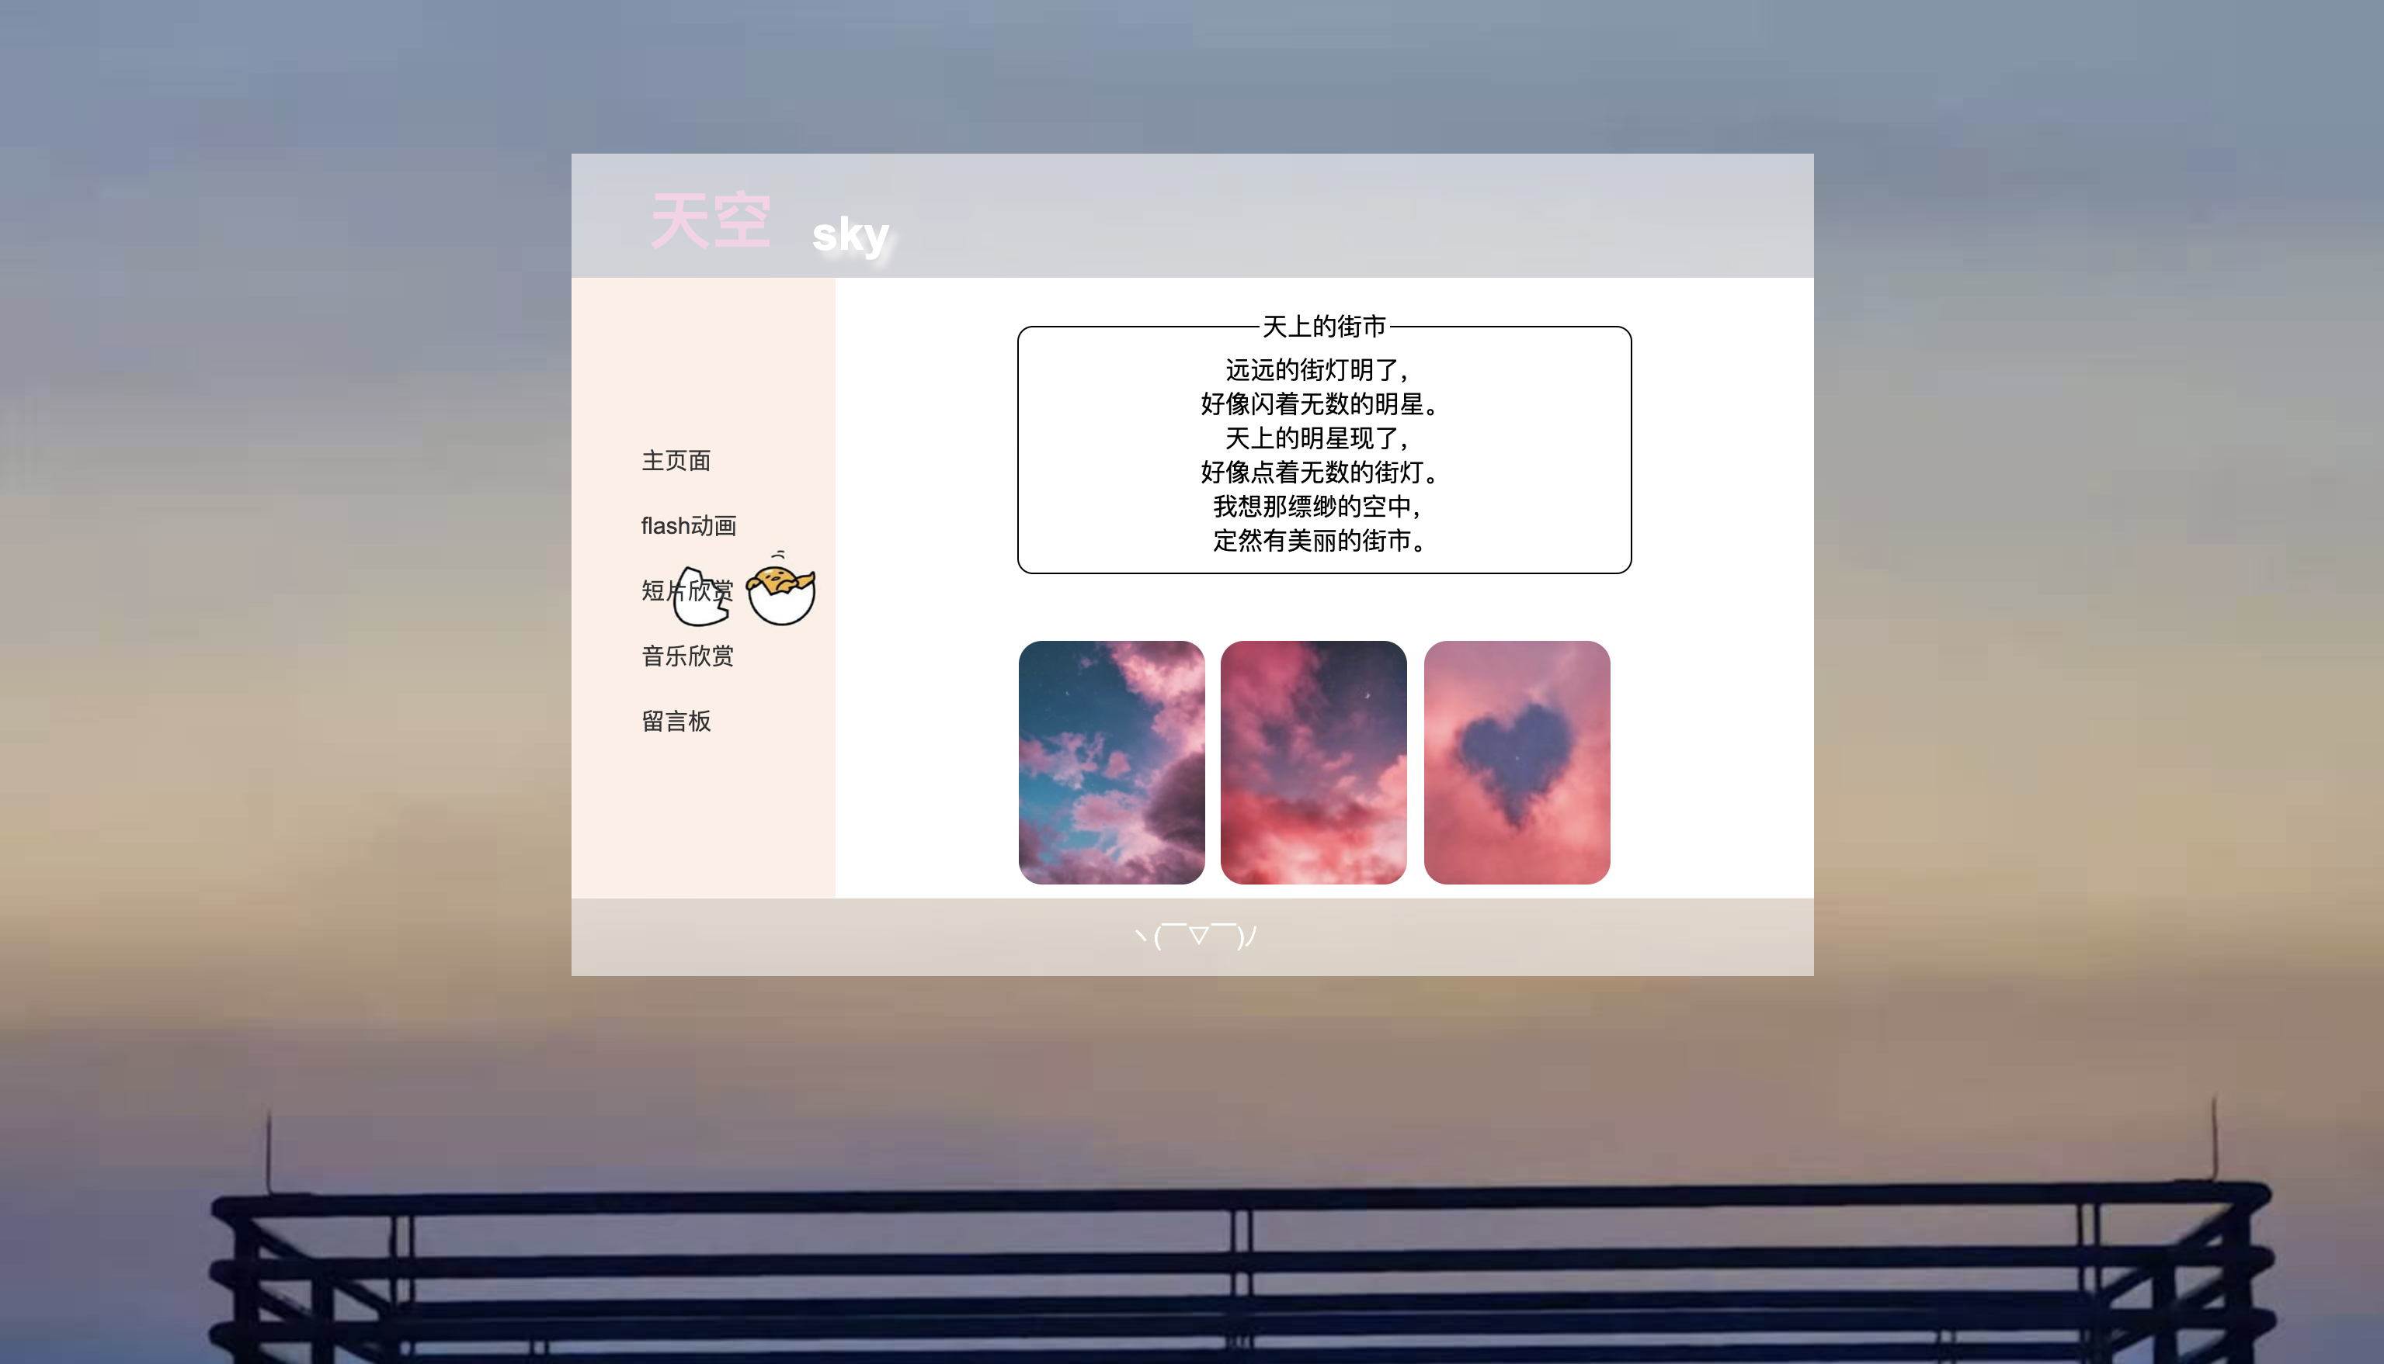

1. Flash动画

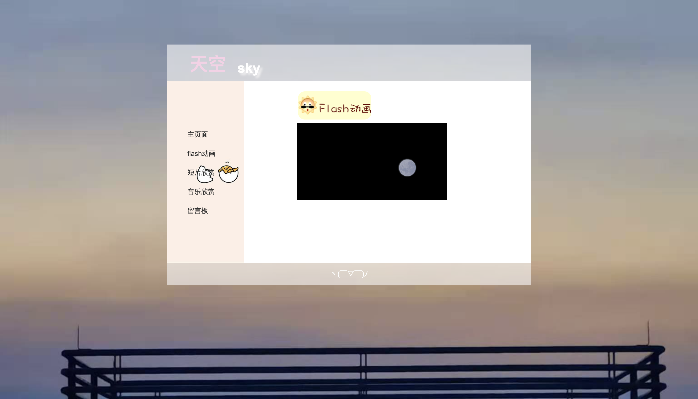

1. 短片欣赏

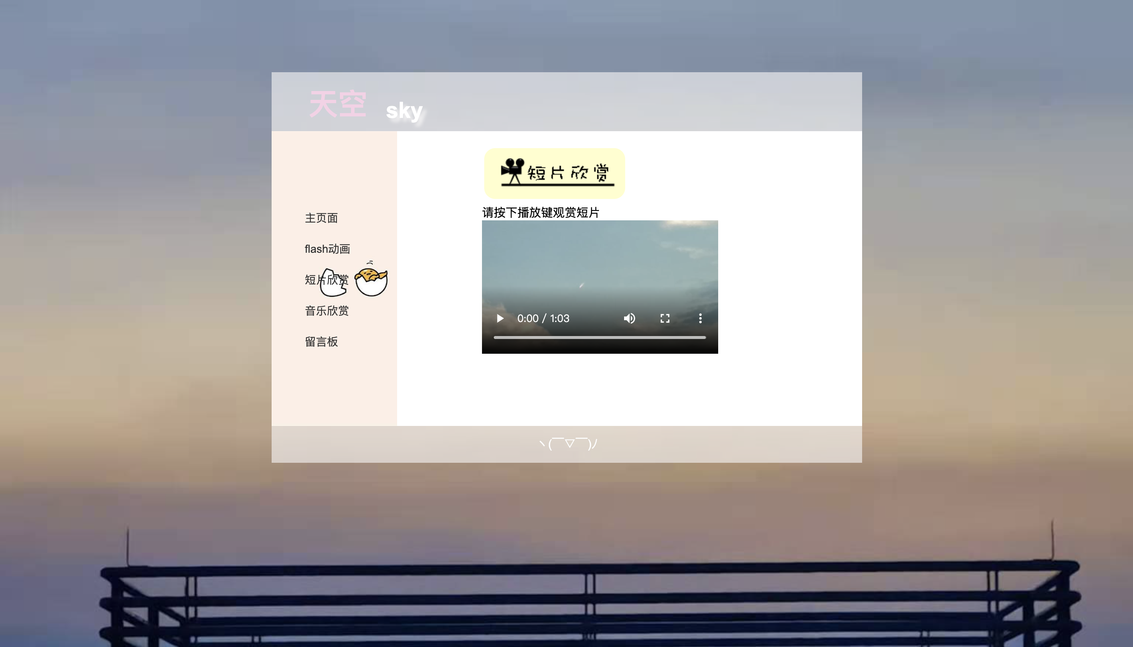

1. 音乐欣赏

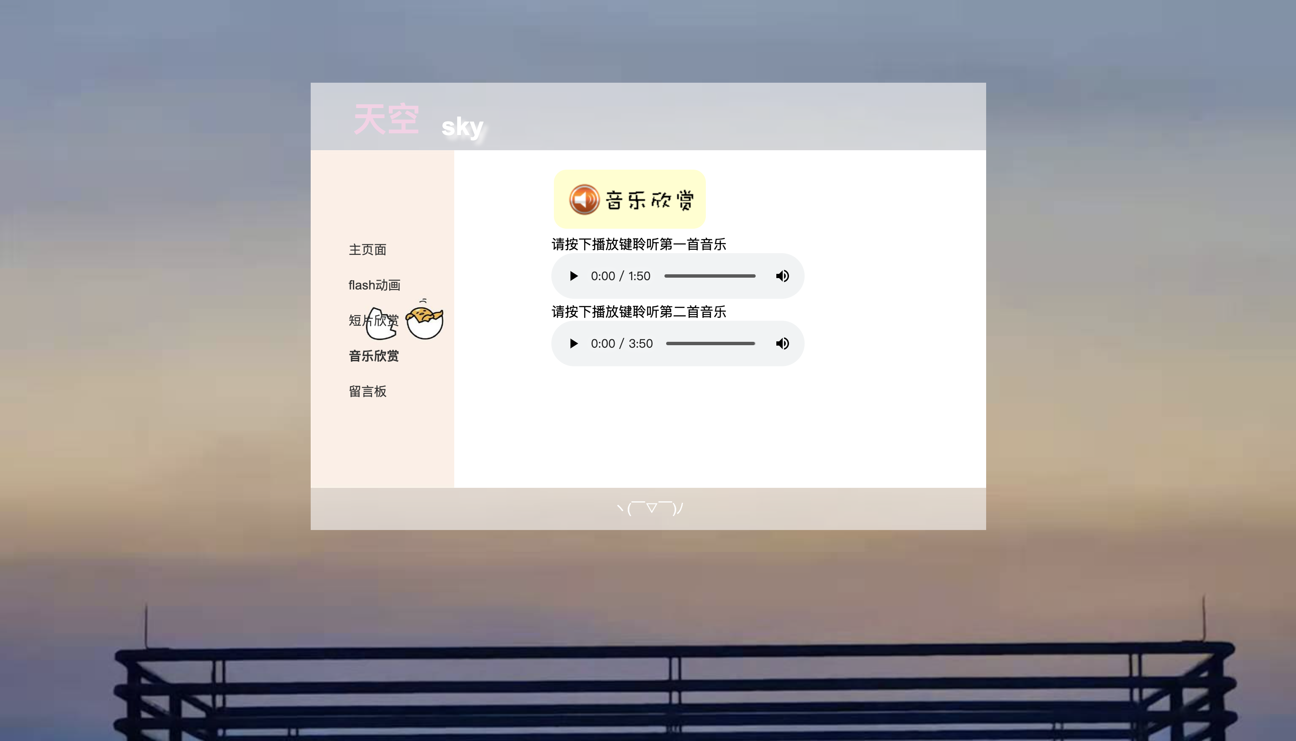

1. 留言板

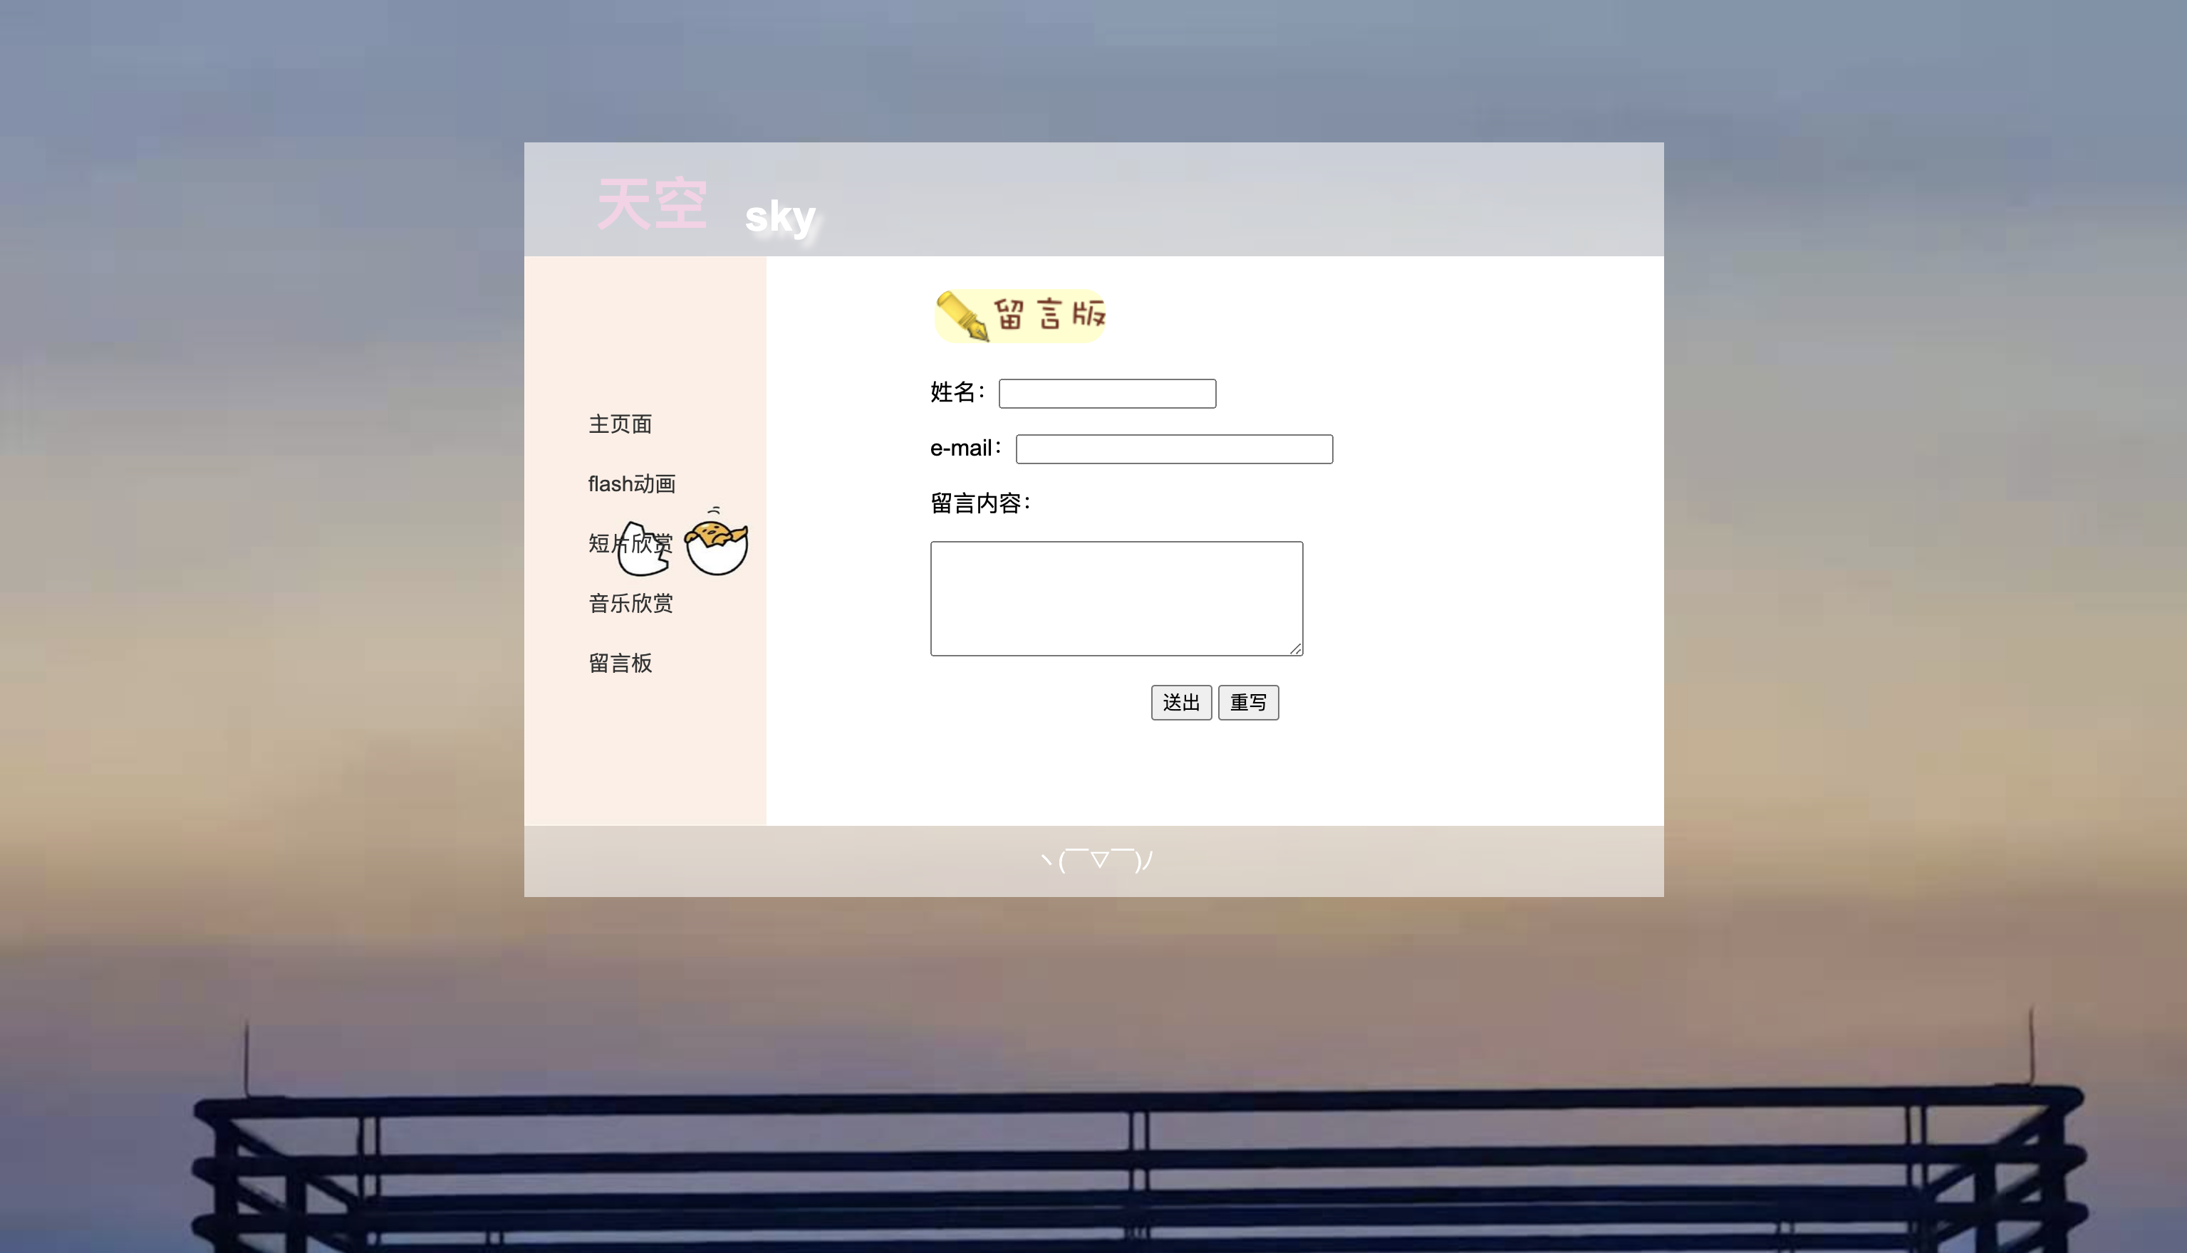

主要代码如下：

1)主页面

<!DOCTYPE html>

<html>

<head>

<title>index</title>

<link rel=stylesheet type="text/css" href="color.css">

</head>

<body>

<div id="main">

<header>

<h1 id="text1">天空</h1>

<h1 id="text2">sky</h1>

</header>

<aside>

<nav>

<ul>

<li><a href="index.htm">主页面</a></li>

<li><a href="flash.htm">flash动画</a></li>

<li><a href="movie.htm">短片欣赏</a></li>

<li><a href="music.htm">音乐欣赏</a></li>

<li><a href="message.htm">留言板</a></li>

</ul>

</nav>

</aside>

<article>

<section class="consection">

<fieldset style="text-align: center;">

<legend>天上的街市</legend>

远远的街灯明了，<br>

好像闪着无数的明星。<br>

天上的明星现了，<br>

好像点着无数的街灯。<br>

我想那缥缈的空中，<br>

定然有美丽的街市。<br>

</fieldset>

</section>

<div class="consection">

<img src="images/sky1.jpg" width="120">

<img src="images/sky2.jpg" width="120">

<img src="images/sky3.jpg" width="120">

</div>

</article>

<footer>ヽ(￣▽￣)ﾉ</footer>

</div>

</body>

</html>

2）flash动画

<!DOCTYPE html>

<html>

<head>

<title>index</title>

<link rel=stylesheet type="text/css" href="color.css">

</head>

<body>

<div id="main">

<header>

<h1 id="text1">天空</h1>

<h1 id="text2">sky</h1>

</header>

<aside>

<nav>

<ul>

<li><a href="index.htm">主页面</a></li>

<li><a href="flash.htm">flash动画</a></li>

<li><a href="movie.htm">短片欣赏</a></li>

<li><a href="music.htm">音乐欣赏</a></li>

<li><a href="message.htm">留言板</a></li>

</ul>

</nav>

</aside>

<article>

<section class="consection">

<img src="images/flash.gif" alt="flash����ͼʾ">

<embed src="moon.swf" width="330" height="170">

</section>

</article>

<footer>ヽ(￣▽￣)ﾉ</footer>

</div>

</body>

</html>

3）短片欣赏

<!DOCTYPE html>

<html>

<head>

<title>index</title>

<link rel=stylesheet type="text/css" href="color.css">

</head>

<body>

<div id="main">

<header>

<h1 id="text1">天空</h1>

<h1 id="text2">sky</h1>

</header>

<aside>

<nav>

<ul>

<li><a href="index.htm">主页面</a></li>

<li><a href="flash.htm">flash动画</a></li>

<li><a href="movie.htm">短片欣赏</a></li>

<li><a href="music.htm">音乐欣赏</a></li>

<li><a href="message.htm">留言板</a></li>

</ul>

</nav>

</aside>

<article>

<section class="consection">

<img src="images/flash.gif" alt="flash����ͼʾ">

<embed src="moon.swf" width="330" height="170">

</section>

</article>

<footer>ヽ(￣▽￣)ﾉ</footer>

</div>

</body>

</html>

4）音乐欣赏

<!DOCTYPE html>

<html>

<head>

<title>index</title>

<link rel=stylesheet type="text/css" href="color.css">

</head>

<body>

<div id="main">

<header>

<h1 id="text1">天空</h1>

<h1 id="text2">sky</h1>

</header>

<aside>

<nav>

<ul>

<li><a href="index.htm">主页面</a></li>

<li><a href="flash.htm">flash动画</a></li>

<li><a href="movie.htm">短片欣赏</a></li>

<li><a href="music.htm">音乐欣赏</a></li>

<li><a href="message.htm">留言板</a></li>

</ul>

</nav>

</aside>

<article>

<section class="consection">

<img src="images/music.gif" alt="��������ͼʾ" /><br />

请按下播放键聆听第一首音乐

<audio controls="controls" style="outline: none;">

<source src="music1.mp3" />

</audio><br />

请按下播放键聆听第二首音乐

<audio controls="controls" style="outline: none;">

<source src="music2.mp3" />

</audio>

</section>

</article>

<footer>ヽ(￣▽￣)ﾉ</footer>

</div>

</body>

</html>

5）留言板

<!DOCTYPE html>

<html>

<head>

<title>index</title>

<link rel=stylesheet type="text/css" href="color.css">

</head>

<body>

<div id="main">

<header>

<h1 id="text1">天空</h1>

<h1 id="text2">sky</h1>

</header>

<aside>

<nav>

<ul>

<li><a href="index.htm">主页面</a></li>

<li><a href="flash.htm">flash动画</a></li>

<li><a href="movie.htm">短片欣赏</a></li>

<li><a href="music.htm">音乐欣赏</a></li>

<li><a href="message.htm">留言板</a></li>

</ul>

</nav>

</aside>

<article>

<section class="consection">

<img src="images/message.gif" alt="���԰�ͼʾ">

<form method="post" enctype="text/plain" action="">

<p>姓名：<input type="text" name="username" size="20">

<p>e-mail：<input type="text" name="e-mail" size="30">

<p>留言内容：</p>

<p><textarea rows="5" name="message" cols="30"></textarea>

<p align="center"><input type="submit" value="送出">

<input type="reset" value="重写">

</form>

</section>

</article>

<footer>ヽ(￣▽￣)ﾉ</footer>

</div>

</body>

</html>

6）整体css

body{

margin:0px;padding:0;

font-family:Arial, Helvetica, sans-serif;

cursor:url('./images/cloud.cur'),url('./images/cloud.png'),auto;

background-image: url('images/bg.jpg');

background-attachment:fixed;

}

#main{

margin: 100px auto;

width:800px;

height:auto;

}

header{

width:800px;

height:80px;

background:#f8f7f79d;

}

aside{

width:170px;

float: left;

height:400px;

background: url('./images/aside.jpg') no-repeat;

background-size: cover;

}

nav{

border:0px #ffffff solid;

margin: 0px auto;padding:0px;

margin-top:100px;

}

nav ul {

list-style:none;

margin:0;padding:0;

}

nav li a {

display:block;

width:150px;

height:42px;

line-height:35px;

text-indent:45px;

text-decoration:none;

color:#333333;

font-size:15px;

}

nav li a:hover {

font-weight: 600;

}

h1#text1{

margin:0px;padding:0px;

top:115px;

position:absolute;

font-size:40px;

color: rgb(248, 209, 230);

margin-left:50px;

}

h1#text2{

margin:0px;padding:5px;

position:absolute;

font-size:30px;

color:#FFFFFF;

top:130px;

margin-left:150px;

filter:glow(color=#f8f6f6d2, strength=5);

text-shadow: 5px 5px 5px #f8f6f6d2;

}

article{

width:630px;

margin-left:170px;

height:400px;

background:#FFFFFF;

}

.consection{

width:400px;

left:10px;top:10px;

margin:0px auto;padding:20px;

}

fieldset{

border:1px solid;

-moz-border-radius: 10px;

-webkit-border-radius: 10px;

border-radius: 10px;

}

fieldset legend{

text-align:center;

}

img{

margin:3px;

border-radius: 15px;

-moz-border-radius: 15px;

-webkit-border-radius: 15px;

}

footer{

background:#f8f7f79d;

color:#ffffff;

width:800px;height:50px;

text-align:center;

line-height:50px;

}